A000-Afr-Cameroon-Fali-Fetish-Early 20th c

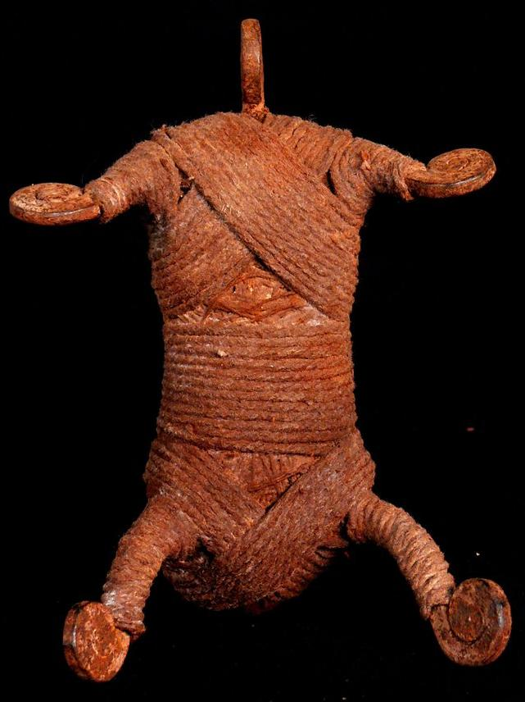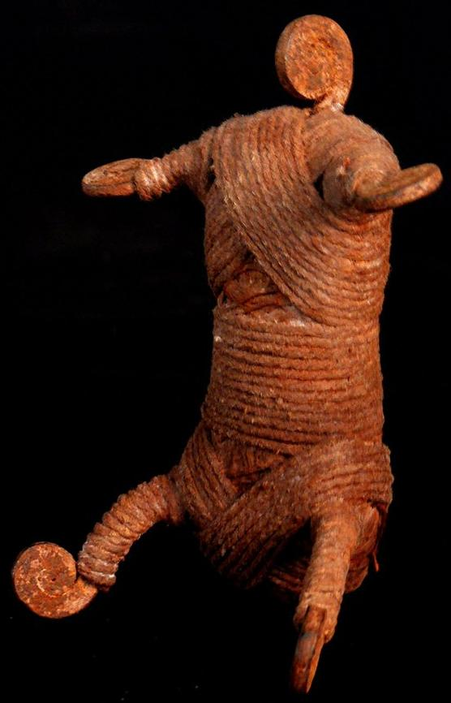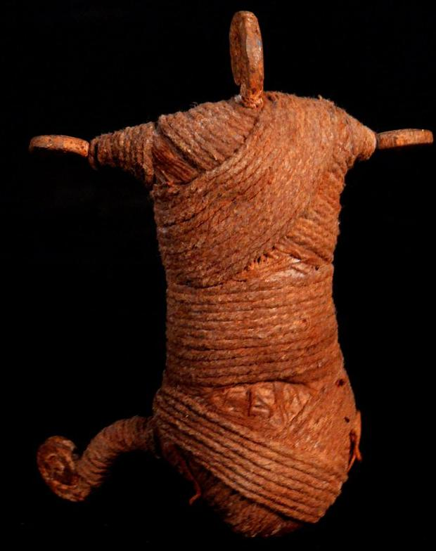

Figs. 1-3. Afr-Cameroon-Fali-Fetish-Early 20th c

Case No.: 6

**Accession No.**

**Formal Label:** Afr-Cameroon-Fali-Fetish-Early 20th c

**Display Description:**

This Fali Fetish from Cameroon dating to the Early 20th c is an unusual protective fetish that is designed to wrap the owner in a secure structure like the tightly wrapped string covering its body.

**LC Classification:**

**Date or Time Horizon:**

**Geographical Area:**

**Map:**

**GPS coordinates:**

**Cultural Affiliation:**

**Media:** steel, cotton twine

**Dimensions:** Size : 6 inches

**Weight:** 0.4 pounds

**Condition:**

**Provenance:**

**Discussion:**

**References:**